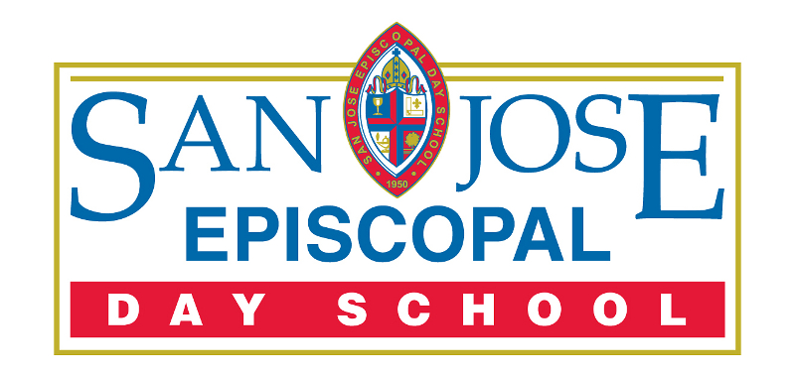

San Jose Episcopal Day School
Family Handbook
2021-2022

7423 San Jose Boulevard
Jacksonville, FL 32217
904-733-0352
www.sjeds.org

San Jose Episcopal Day School

FULLY ACCREDITED BY:

The Florida Council of Independent Schools (FCIS)

MEMBERSHIPS:

Association of Independent School Admission Professionals (AISAP)

Association for Supervision and Curriculum Development (ASCD)

Board of Regents Episcopal Diocese of Florida (BREDF)

Independent School Management (ISM)

National Association of Episcopal Schools (NAES)

National Association of Independent Schools (NAIS)

National Business Officers Association (NBOA)

For additional information call the school office at 904-733-0352
or visit our website at www.sjeds.org

In the spirit of the Episcopal Church, San Jose Episcopal Day School welcomes qualified applicants and does not discriminate on the basis of race, color, sex, religion, national or ethnic origin in administration of our educational policies, admissions, financial aid programs, or athletic and other school-administered programs.

TABLE OF CONTENTS
Guiding Documents | 3-6
History | 6
Administrative and School Offices | 7
Financial Information | 8-9
Attendance Policies and Procedures | 9-10
Carpool and Parking Procedures | 10-12
Assessments | 12-13
Behavior | 15-18
Policies and Procedures for Grievance | 18-19
School Services | 19-22
General Information | 23-26
Student Activities and After School Enrichment | 26
Technology and Network Usage Policy | 26-28
Policies | 28-31
Parents’ Association | 31
Uniforms and Personal Appearance Code | 31-32

SAN JOSE EPISCOPAL DAY SCHOOL

OUR MISSION:

Inspiring a passion for learning, a life of integrity,
and a heart for Christian service

Statement of Philosophy

A passion for learning
We believe that relationships are central to our learning community, and the relationships between students, teachers and families are vital to the learning process. We value extraordinary teachers who support students in the discovery and development of their gifts and talents. We celebrate passionate, self-motivated, lifelong learners. To prepare students for success in an ever-changing world, we embrace learning experiences that allow students to develop creative problem-solving skills and critical thinking. We empower students to take a responsible role in their learning and support independent thought. We provide a safe and supportive environment and encourage children to be adventurous, to take risks and to view failure as integral to learning. We celebrate student effort and growth, embrace the value of the learning process, and promote perseverance and reflection.

A life of integrity
We value the development of character and integrity above academic pursuits. We believe an integral component of our curriculum is spiritual development, which is woven throughout the fabric of our learning community. We promote students taking responsibility for their actions. We provide leadership opportunities for students so they may experience the power and potential of an individual’s influence on his or her community and the world. Above all, we encourage students to practice empathy and to be role models in treating others with compassion, love and kindness.

A heart for Christian service
We understand that all people are worthy of respect and dignity and believe we are all part of an interconnected world. We value diversity of thought, background, religion, and race, and know that diversity nurtures compassion and empathy. We live out our faith in a relational, caring manner and are responsible stewards of our world and environment, realizing that our local actions impact our global community. We experience the joy of making a difference for others through service-learning. We recognize social involvement and sharing the Good News as hallmarks of our Episcopal identity.

Faculty Characteristics of Professional Excellence

The following characteristics reflect our mission expressed through the lives and work of our faculty and staff.

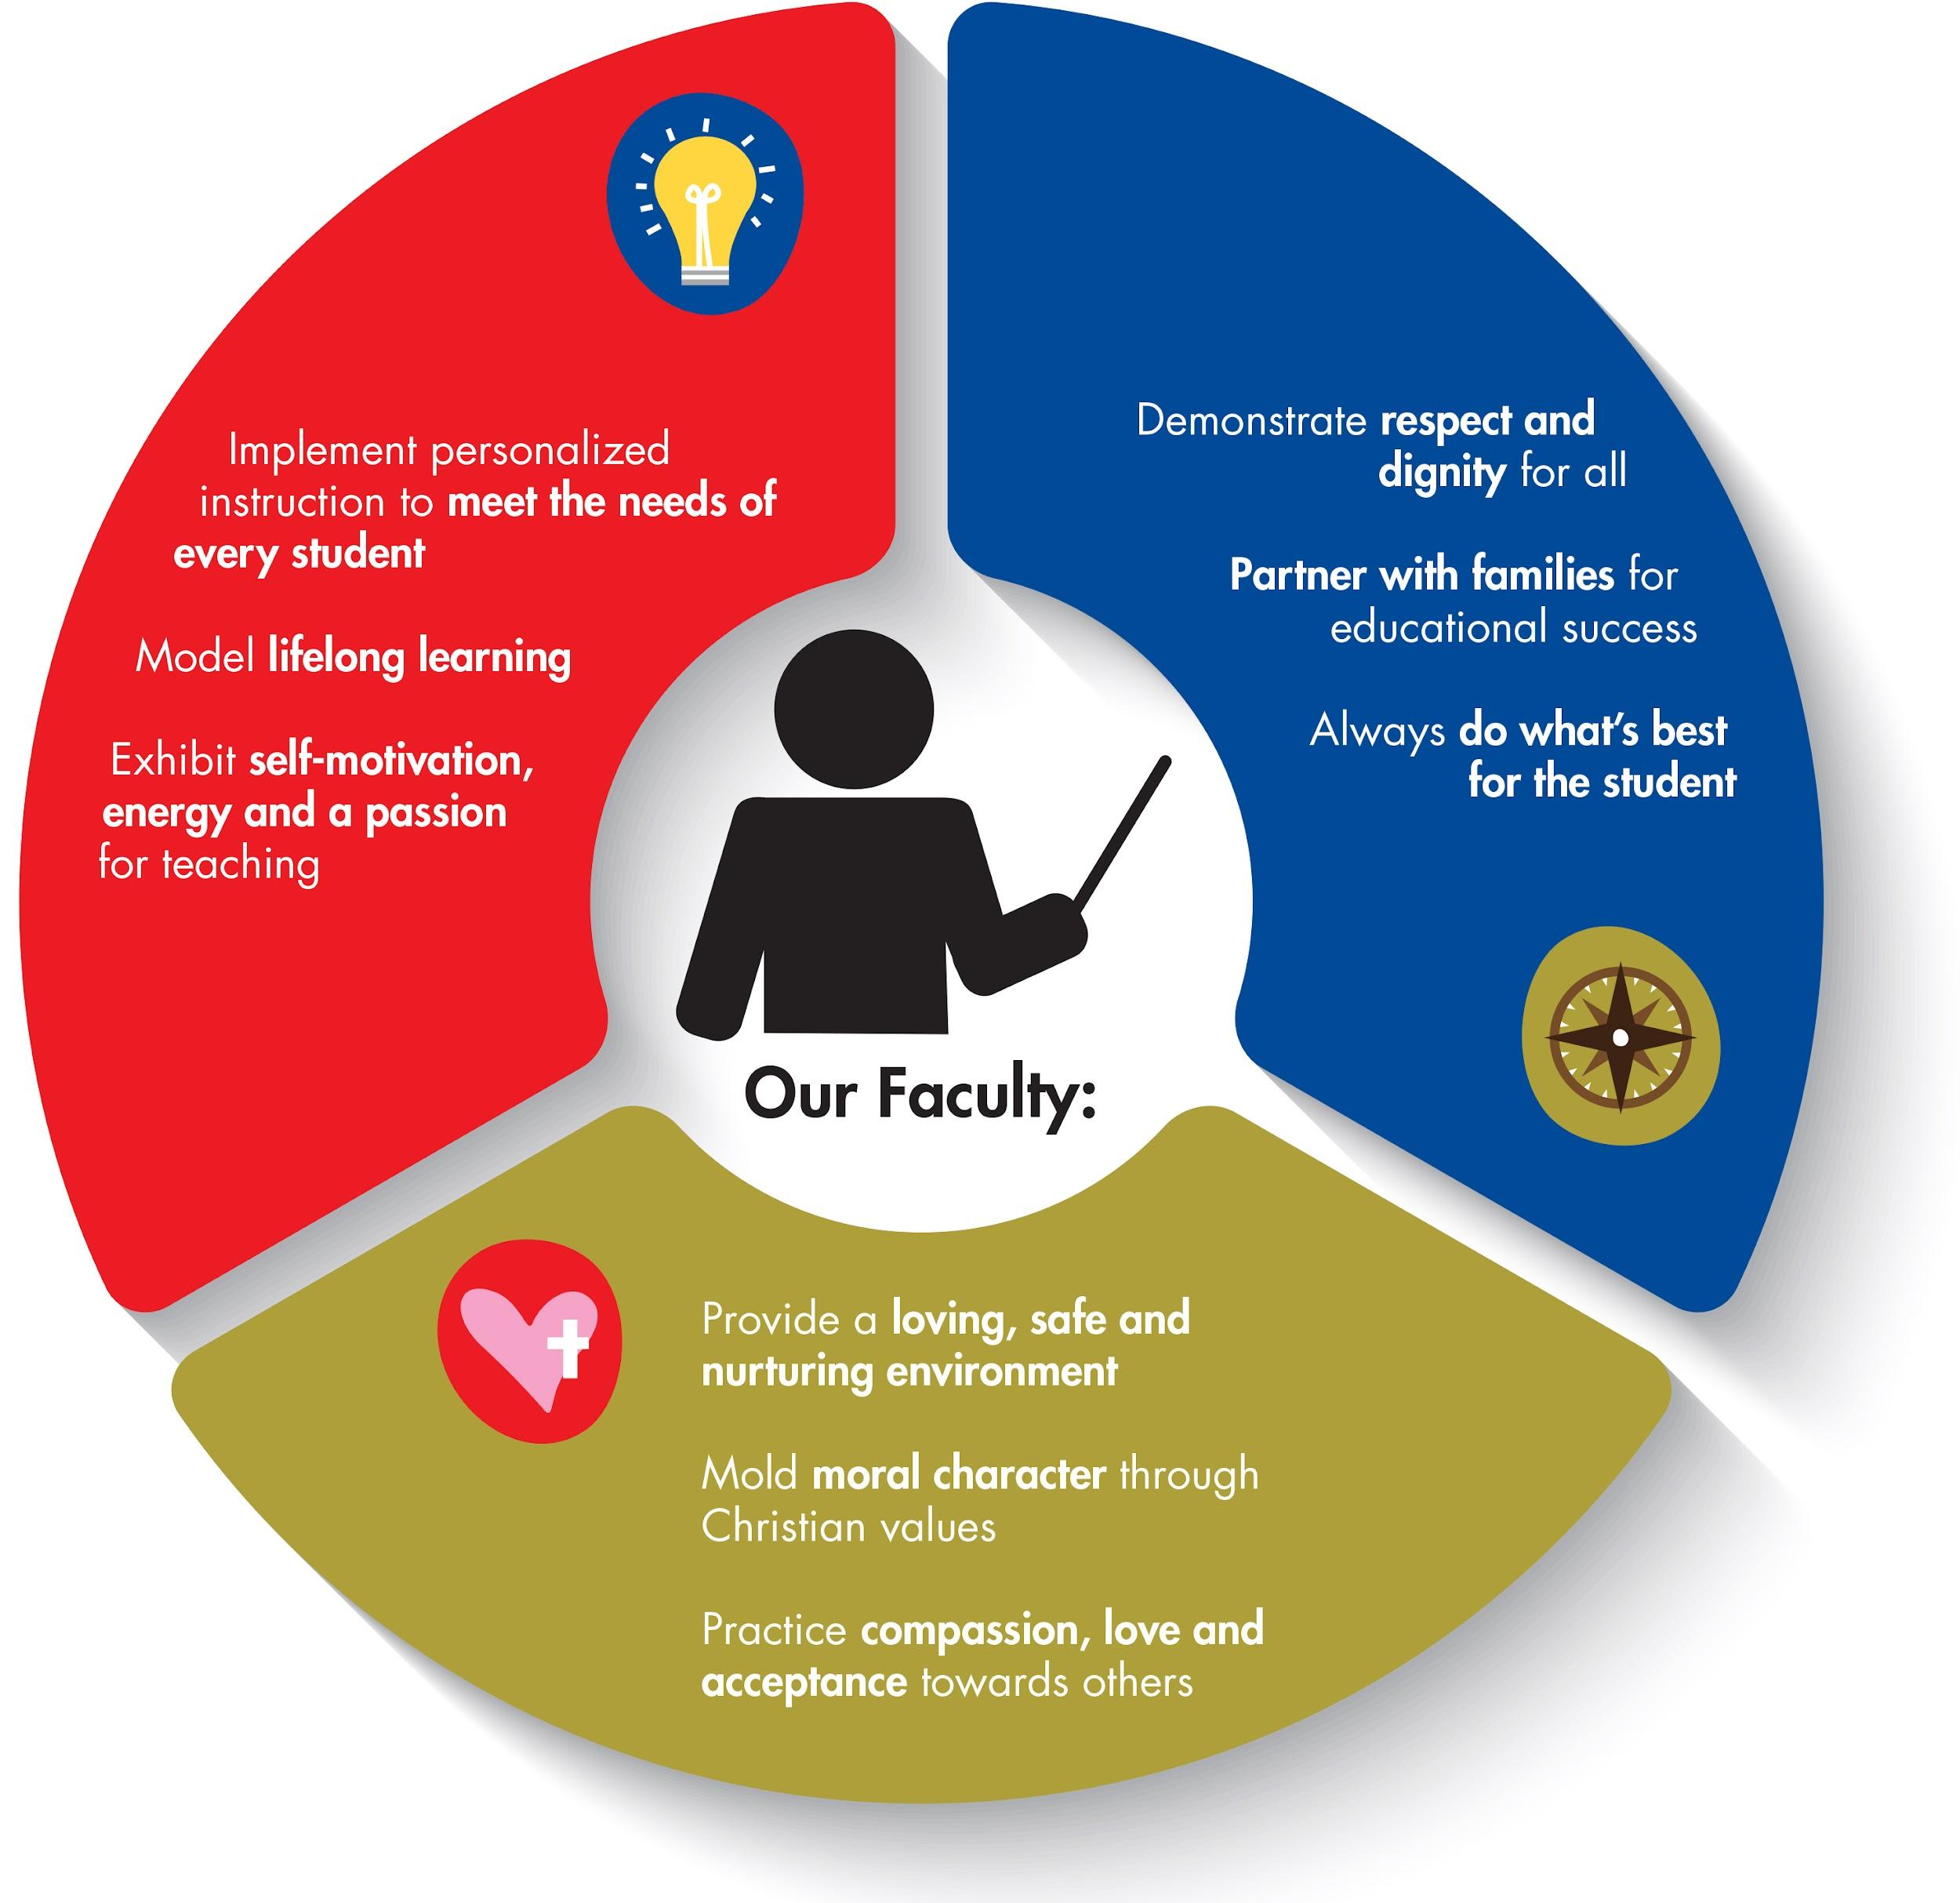

Portrait of a San Jose Episcopal Day School Graduate

The following characteristics reflect the outcome of our mission expressed through the lives of our students.

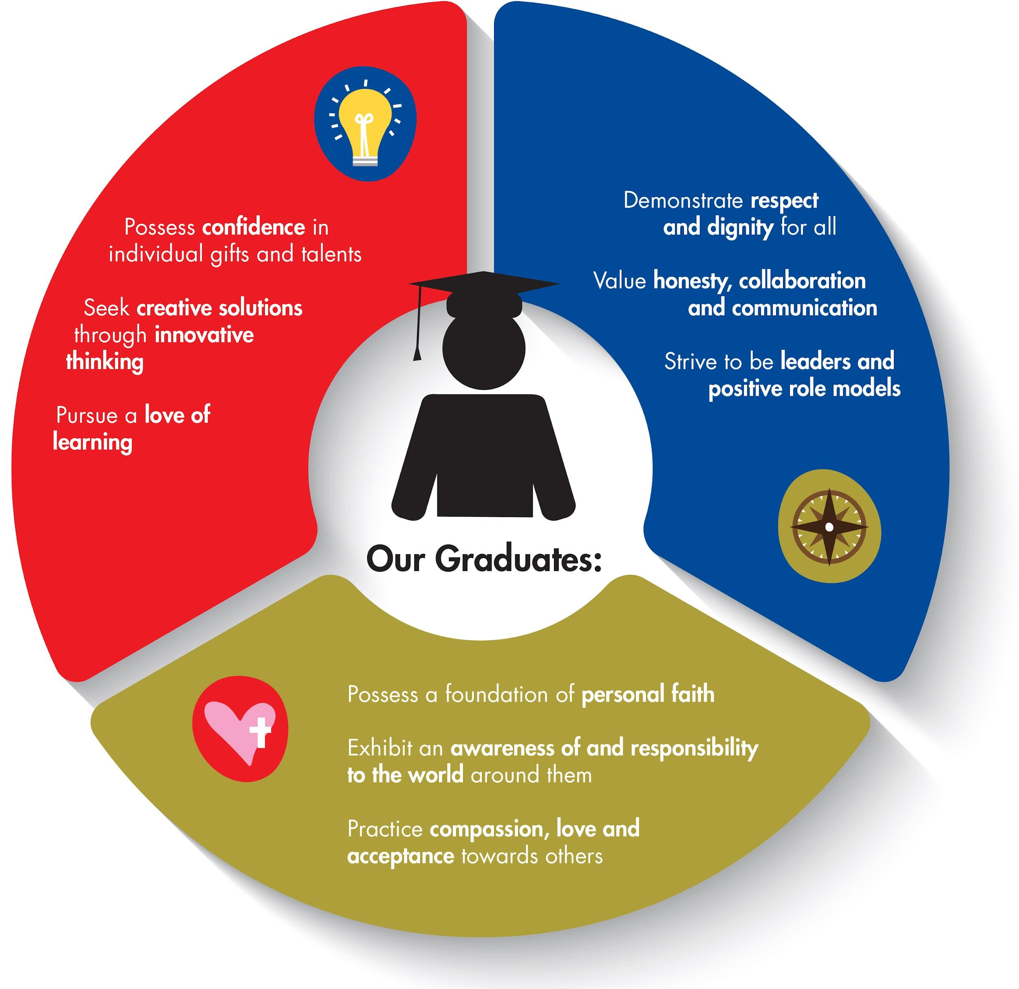

Governance
The school is a mission of San Jose Episcopal Church. The Board of Trustees and Vestry are the guardians of the school's mission. It is the responsibility of the Board and Vestry to ensure that the mission is appropriate, relevant, and vital to the community it serves. They are also responsible for the financial well-being of the school. The Board of Trustees, Vestry, Rector, and Head of School work in partnership in fulfilling these principles.

History
In the early 1920s, the San Jose Estates Development Company was in the midst of establishing a premier suburban residential community with plans for hundreds of homes, two hotels, a country club, a school, and a shopping center. The administrative building for the development company existed on the present site of San Jose Episcopal. Evidence of the development company can still be seen today in the crest emblazoned on the front and back of the school with the monogram SJE. The project ended in 1926, with many of the buildings never coming to completion, when the anticipated real estate boom was not realized.

After the collapse of the San Jose Development Company, the land and buildings were purchased by Alfred I. duPont. For a brief time, the property housed a Roaring Twenties casino and even a gas station. In the late 1930s, Alfred I. duPont’s widow, Mrs. Jessie Ball duPont, allowed some neighborhood Episcopalians to use the administration building for worship services and later as a chapel for students, and it was known as Grace Chapel. Mrs. duPont donated the property to the Episcopal Diocese of Florida in 1941 and Grace Chapel became a parish. In 1971, the name was changed to San Jose Episcopal Church, giving the initials S.J.E. in the crest new meaning.

The Day School began as a mission of the church with a Kindergarten program and was established to provide excellent academics in a Christian environment. This tradition continues today and the school has expanded and grown to now serve students in grades Pre-K3 through sixth grade.

In 1985, San Jose Episcopal Day School and San Jose Episcopal Church were honored and listed on the National Register of Historic Places. The original building now forms the centerpiece of San Jose Episcopal Day School.

ADMINISTRATIVE AND SCHOOL OFFICES
Admission Policy
When completed application packets are received, they are reviewed by the Admission Committee. Applicants are evaluated on the basis of the application which may include school records, teacher recommendations, observations, and admission assessments. Taken into consideration are academic skills, motivation to learn, developmental and social readiness, talents and personal interests.

Through this process, the school seeks to admit students who: demonstrate a likelihood to thrive within a challenging academic environment, possess high moral character, and demonstrate appropriate social adjustment. Priority is given to siblings of currently enrolled students, church members, and children of alumni.

It is the mission of San Jose Episcopal Day School to foster a Christian environment that allows each student to experience the richness of Christianity through the rites and traditions of the Episcopal Church. While affiliated with San Jose Episcopal Church, the school serves students of all faiths.

Students and parents must willingly and actively participate in the complete program and partner with the school to achieve the desired benefits of the program. Cooperation with the faculty and staff and ability to maintain desirable relationships with others in the school community is essential. School policy does not permit anyone who serves as a disturbing factor to jeopardize the success of others enrolled in the school. In the best interest of the school, the Head of School may require a disruptive student or parent to be withdrawn.

Business Office
The Business Office is responsible for school financial transactions. The Business Office is located next to the school office and is open during regular school hours. For your convenience, there is a drop box in the door of the school office should you need to drop off something before or after school.

Development
The Development Office provides the human and financial resources necessary to assure the future viability of the school. SJEDS is a non-profit, 501(c)(3) independent school, and therefore does not receive any funding from the government. Tuition alone does not cover all of the school’s expenses, so like many independent schools, the school relies on additional annual funding to provide an exceptional yet affordable education without substantial tuition increases.
The Fund for San Jose, the annual giving campaign, helps bridge the gap between what tuition covers and what it costs to provide the standards of excellence for which the school is known. Each year, every member of the SJEDS community is asked to make a donation by June 30. Your participation, no matter the size of your gift, is key. Gifts may be broken into monthly payments and added to your tuition. Please know that every dollar of your tax-deductible gift is put to its best use and allows the school to provide a richer learning experience for every student.
Personnel
SJEDS faculty and staff are valued by our families for caring attitudes, Christian values, intelligence, creative teaching ability, loyalty, and responsibility. All employees are required by the Diocese of Florida to submit to a background check, including fingerprinting, to take Safeguarding God’s People and Safeguarding God’s Children courses, and abide by the Standards of Ethical Conduct according to Florida Statutes. All faculty members must meet the standards set forth by FCIS.

FINANCIAL INFORMATION
Continuous Enrollment Contracts
When registering as a new student, parents are asked to read and sign a Continuous Enrollment Contract for each child enrolled in the school. The Continuous Enrollment Contract addresses financial requirements and policies set forth by the school. Parental signature represents a binding commitment to uphold the school's policies and financial requirements. By signing the Continuous Enrollment Contract, it verifies that you have read and understood the Family Handbook. Students on Continuous Enrollment Contracts that remain enrolled during the opt-out period agree that they have read and understood updates to the Family Handbook.

The following documents are required at registration with a deadline of one week prior to the first day of school (for all students):
- A photocopy of the registered birth certificate
- A completed Student Physical Examination form (HRS Form 3040)
- A Certificate of Immunization (HRS Form 680). SJEDS does not accept religious exemptions for vaccinations.
- Student Emergency Form (will be sent to parents via email)

Early Arrival
Early Arrival is available in the Gym starting at 7:30 a.m. each day at no charge for families who are enrolled in the Extended Day program.

Extended Day Program/Monthly or Occasional Care
In order to enroll in the Extended Day Program (monthly or occasional care), a registration fee will be charged to your account. Monthly care will be charged in advance and occasional care will be charged at the end of the month of use.

The school is grateful to military families and appreciates their service to our country. If a parent is deployed, SJEDS is happy to offer Extended Day services at a discounted rate during the deployment period.

Late Payment Policy
The school requires prompt payment of all tuition and fees. Your signed contract represents your financial commitment and obligation to the school. Your account is considered in arrears if the current bill is not paid within 30 days of the due date. Accounts in arrears will be charged a late fee equivalent to 1.5% of the past due balance.

Also, past due accounts are subject to the following:
- Teacher Assignments (including teacher announcement emails and postcards), Midterm Progress Reports, Report Cards, testing results, diplomas, and transcripts may not be released.
- Your child may be prevented from attending class, field trips, Extended Day, or Afterschool activities.

Lost/Damaged School Property
Textbooks, workbooks, instruments and other school property – The school will charge the parent’s SMART Tuition account the replacement cost for textbooks, workbooks, instruments, technology equipment and other school property distributed to the student that is lost or damaged.

Library books - If a library book is lost or damaged, parents will be charged $25 for hardcover books and $15 for paperback books. The library cannot accept replacement books purchased from a book store in lieu of paying for the book.

Refund Policy
Once the enrollment contract has been signed, your child is enrolled for the next full school year. The school will not refund the deposit, regardless of the reason for the child’s non-attendance at school. In addition, the parent becomes responsible for the full year’s tuition, regardless of the reason for the child’s non-attendance at school.

There are only two limited exceptions to this policy. The school may refund unused tuition payments, but not the non-refundable enrollment deposit, if:
- the parent provides documentation to the school’s satisfaction before the start of the school year establishing that the parent has been transferred to a location that will not reasonably allow the student to attend the school, or
- the parent provides documentation before the start of the school year to the school’s satisfaction establishing a medically verified illness that would prevent the student from attending the school.
The school reserves the right to request additional information from either the parent’s employer or the child’s physician regarding the reason for withdrawal.

Returned Check Policy
There is a $25 fee charged for any check returned unpaid by the bank. Please advise the school immediately if your check is returned unpaid. The school will resubmit the check to the bank (allowed once by most banks) or will require payment in cash, money order or cashier’s check.

ATTENDANCE POLICIES AND PROCEDURES
It is essential for students to be active participants in all class activities to receive a successful education. This includes Pre-K3 through sixth-grade students. The school day begins at 8 a.m. and dismisses at 1:00 p.m. (Pre-K3 and Pre-K4) and 3:00 p.m. (Kindergarten - 6th grade).

Attendance Records
An excessive number of tardies, early departures, and/or absences may affect the school’s decision to offer re-enrollment to your child and/or your child’s ability to progress to the next grade level. The school reserves the right to determine the student’s ability to move to the next grade. In certain instances, a test may be given to a student who has missed an excessive amount of school. This test would be based on material covered in the current grade, and the student’s satisfactory completion of this material. Attendance records are kept for the regular classroom as well as the resource classes. The school office tracks absences, tardies, and early dismissals.

Tardy
Students arriving after the 8:05 a.m bell will be marked tardy. They must be escorted by a parent and signed in at the school office. The student will be given a tardy slip. A student will not be admitted to class after 8:05 a.m. without a tardy slip. After five tardies, an absence will be recorded.

Illness
To prevent the spread of illness, keep any child home who has been ill during the past 24 HOURS. Inform the school about any illness that is causing your child to miss school for three days or more. Please notify the school about confirmed conditions that are highly contagious including, but not limited to, strep throat, influenza, COVID-19, lice, etc.

Students in school for at least four hours of the school day are marked present. Students not in school for a total of four hours are marked absent.

Make-up Work for Absences
It is the student's responsibility to make up or complete all classwork, homework, quizzes, and tests missed during an absence. Students are given the same number of days they have missed to make up their work.

For any absence, the student should check with the teacher, call a fellow student or ask for assignments upon return to school. For absences of two days or more, parents may call the school office before 10:00 a.m. to request assignments. The homework assignments will be available in the school office at an agreed upon time. The teacher has discretion and may specify exactly what is to be made up and to permit extension of the make-up schedule beyond the regulation time.

Early Dismissal From School
When students need to leave during school hours, parents must notify their classroom teacher in advance. Parents must sign out their child in the school office and state the reason for the early departure.

Changes to a student’s carpool direction must be sent by email to the teacher and the school office (office@sjeds.org). If there are any carpool changes after 2:00 p.m., please call the office at 733-0352. NOTE: When carpool has ended, those students not picked up from carpool will be escorted to Extended Day, and parents will be billed accordingly. Parents do not need to call the office to arrange this. Students will not be released early from school to family, friends, neighbors, etc. without permission from the parent.

CARPOOL AND PARKING PROCEDURES

Please adhere to the following procedures for the safety of every child. Review these procedures carefully and discuss them with your child.

Arrival
7:30 – 8 a.m. Early arrival in the gym.
8:00 a.m. Early arrival students are dismissed from the gym to their classrooms
Carpool students arriving after 8:00 go directly to their classrooms
8:00 a.m. First Bell: All students should be in their classroom
8:05 a.m. Tardy Bell: After 8:05 a.m. parents must escort their children directly to
the front office to check in.

Due to staffing duties, safety protocol, and classroom instruction
ALL GATES WILL BE LOCKED PROMPTLY AT 8:05 a.m.! It is so important for the children to be on time...please help us with this.

Students should arrive with adequate time to reach their classroom before the Tardy Bell. The drop-off location is in the front driveway for all grades. As children exit their cars, temperatures will be checked. Children who have a temperature of 100.4 or above will be placed back in their car.

Cars line up on the eastside of San Jose in the parking lane. When exiting onto San Jose Boulevard, do not turn left due to heavy traffic. For safety reasons, school patrol members open and close car doors for students from the passenger side only. School Patrol "walkers'' are provided for younger students needing an escort to their rooms.

FOR YOUR CHILD’S SAFETY:
- Students should be dropped off in the carpool line.
- Students should remain in the car until assisted by an adult or patrol.
- We discourage parents from walking older students to the classrooms. It is important they begin to learn to be independent and transition easily for a smooth start to school.
- If you must walk your child to his/her classroom, then we ask that you cross at the crosswalk.

Supervised Early Arrival
Parents are responsible for making sure their child enters Early Arrival safely. Students may not travel the school grounds without supervision. For your child’s safety, students must remain supervised by a parent until the doors open and faculty receives them. Parents must make sure the child has entered the building before leaving.
Parents walking children to classes in the morning should promptly drop off the student and refrain from engaging the teacher in conversation or entering the classroom. It is important that the teacher devotes his or her attention to the class.

School playgrounds are off-limits to students and parents before and after school.

Dismissal
1:00 p.m. Pre-K3, Pre-K4
3:00 p.m. Kindergarten – 6th grade

On half days, Pre-K3 through 6th grade are dismissed at noon in the carpool line (front parking lot).

The first Thursday of the month Grades K-6 are dismissed at 2:00p.m.

Carpool Traffic Flow
The school's front driveway is busy and congested so extreme care and consideration is necessary when arriving and departing. Cell phone use is prohibited. For both morning arrivals and afternoon departures, the front driveway is blocked to receive one-lane traffic only.

- Be considerate of those waiting in line. When traveling south on San Jose Boulevard, circle the block to avoid making a left turn into the school.

- By order of the Jacksonville Sheriff’s Office, cars in the right lane on St. Augustine Road approaching the light on San Jose Boulevard must turn right when the light turns green. If the parking lane on San Jose Boulevard is full, circle the block again.

Carpool Identification
In order to expedite afternoon dismissal, all cars must display carpool signs. Official SJEDS carpool signs will be distributed to each family and are required for pick-up. Your carpool sign should be displayed from the passenger visor or rearview mirror and must remain there until your child is in the car. Please do not place carpool signs on the dash. Be sure the name shows right side up and not in the heavily tinted part of the windshield.

Parking
When visiting the school during the day, park on San Jose Boulevard or Via De La Reina whenever possible. Unnumbered parking spaces in the front parking lot may be used on a short-term basis between the hours of 8:30 a.m. and 2:15 p.m. Designated and church parking spaces should not be used. Please do not park in reserved parking spaces.

ASSESSMENTS
Pre-K3, Pre-K4, and Kindergarten
Children are continuously assessed in Pre-K3, Pre-K4, and Kindergarten. Skills are introduced, practice is provided, and mastery is noted. Teachers communicate with parents on a regular basis. In Pre-K3, Pre-K4, and Kindergarten, report cards are sent home at the end of each trimester. Parents are invited to participate in a conference with classroom teachers in the fall and spring. Other conferences may be scheduled as necessary during the year.

Pre-K3, Pre-K4, and Kindergarten
CD Consistently Demonstrated
D Developing
ND Not Demonstrated at this time

Grades 1 – 6
An evaluation of the student by the teacher is intended to give a general picture of a child's progress. Assessment is based on many observable facets of a child's performance in the classroom. This may include class participation, active interest in discussion, quality of homework and classwork as well as assignments, quizzes, tests, projects, and portfolios. Letter grades based upon number percentages will be given in grades three through six.

Grades 1 – 2
E Excellent
VG Very Good
S Satisfactory
NI Needs Improvement

Grades 3 - 6
A+ = 98-100 A = 93-97 A- = 90-92 Excellent
B+ = 88-89 B = 83-87 B- = 80-82 Above Average
C+ = 78-79 C = 73-77 C- = 70-72 Average
D+ = 68-69 D = 63-67 D- = 60-62 Below Average
F = 59 or Below

Resource Grades 1 - 6
M Meets Expectations
NI Needs Improvement

Academic and Resource Subjects
The following subjects are considered academic subjects: language arts, math, social studies and science. Resource subjects are physical education, Kingdom Theatre, Spanish, art, drama, library media, and music.

Grading Periods
The academic year is divided into trimesters. Academic progress is communicated to students and parents midway through each trimester and at the end of each trimester.

In grades 3 - 6, parents will be notified if a student is making a C, D or an F on a Midterm Progress Report or Report Card by the teacher prior to the Report Card coming home. In grades PreK 3 - 2, parents will be notified if a student is struggling in a certain area prior to the Midterm Progress Report Card or Report Card coming home.

Midterm Progress Reports
The Midterm Progress Report is designed to provide students and parents a review of the student's academic progress, citizenship, and work habits. Parents are notified in resource areas only if there is a concern.

Report Cards
The Report Card is designed to provide students and parents a review of the student's academic progress, citizenship, and work habits for the preceding trimester. Attendance and tardy records are included on the Report Card. The Report Card is permanently kept on file in the student’s cumulative folder.

BEHAVIOR MANAGEMENT
Behavior Philosophy
The School’s behavior philosophy centers around positive reinforcement and consequences that seek to encourage responsibility for actions, respect for others, kindness to all, and accountability to one another. In all grade levels, every effort is made to maintain the dignity of the student. Our philosophy recognizes that all children are individuals and each situation is unique and allows the teacher and administrators the flexibility to respond appropriately to each student and situation individually.

Early Explorers and Lower School School Behavior Management Plan (Grades PreK3 - 3)
In Early Explorers and Lower School, the behavior management system varies from class to class while upholding the school’s philosophy. All teachers use positive reinforcement as the basis of their plan and have their own method of implementation. The method used is explained to parents at Open House. The teachers will communicate with parents regarding student behavior on an as-needed basis.

Upper School Behavior Management Plan (Grades 4-6)
In the Upper School students are encouraged through the use of positive reinforcement. However, when needed a system of Yellow Cards and Red Cards is utilized. A folder travels with students throughout their daily routine. The first time a student is spoken to their name is written in the folder. If the student is spoken to again then a Yellow Card is issued. The offenses may be unrelated and a Yellow Card is issued for being spoken to twice, not for being spoken to twice for the same offense. Yellow Cards will be issued in the areas of uniform, materials/class preparation, and behavior. The student will be required to write a short reflection. Three Yellow Cards in any area will result in receiving a Red Card. Each Yellow or Red Card will list the behavior, date, and be signed by the student and faculty member. Yellow and Red Cards may be issued by any faculty member or administrator. Red cards may be issued at school or school sanctioned events including field trips and Extended Day.

A student receiving a Red Card will be sent to the office. The issue of a Red Card may result in detention, or another corrective measure deemed appropriate. Depending on the severity of the infraction, a student may directly receive a Red Card without the issuance of a Yellow Card, and corrective action administered. If a student has been required to serve two or more detentions, parents and the student may be required to come in for a conference with the administration. In more serious cases, a student may be required to serve an in-school suspension or out-of-school suspension. A student who serves an out-of-school suspension will be required to make up all work, which will be assigned at the discretion of the teacher. Extreme cases may result in expulsion and termination of a student’s contract.

1st Offense  (name and checks reset every day) | - Student writes their name in the yellow folder that travels with the class  - Teacher assigns a consequence that corresponds to the behavior
2nd Offense/Yellow Card | - A check is placed next to the student’s name  - Student receives a yellow card  - Student completes a written Personal Reflection
3rd Offense yields a 2nd Yellow Card | - Lunch is eaten in the office or a side room in the lunchroom on a designated day  - Other corrective action(s) as deemed appropriate by the administration.
4th Offense/Red Card (Equivalent to 3 Yellow Cards) | - Student automatically receives a Red Card and is sent to the office where further consequences will be implemented according to the Code of Conduct

*Names and checks in the traveling folder are reset at the beginning of each day.
*Yellow Cards DO NOT reset at the beginning of each day. Yellow Cards only reset at the beginning of the trimester.
*If a child receives a Red Card during the trimester, the behavior cycle starts over.
*The teacher has discretion for the consequence assigned for the offense.
*The yellow folder will travel between academic subjects and resource classes.

Materials and Supplies
- Each student is responsible for their class preparation with regards to materials and supplies. Students will receive one “Responsibility Grade” per subject (Math, Science, Social Studies, Language Arts) This grade is equivalent to just one classwork assignment. Students begin each trimester with a 100% Responsibility Grade for each subject. One point will be deducted from this percentage for each time the student is not prepared with regards to materials and/or supplies in class.
- If a student forgets supplies and has to leave the room to retrieve them, one point is deducted from the “Responsibility Grade” for that subject. The Responsibility Grade is reset to 100% at the beginning of each trimester.
- Parents are notified weekly on tracking sheets if any points have been deducted.

Dress Code
- Students need to adhere to the dress code of San Jose Episcopal Day School.
- Students will be rewarded weekly for adhering to the full dress code policy.
- If a student is not in dress code a Dress Code Referral form is completed. This form includes the date, description, and faculty or administrator completing the form.
- Parents will be notified of a Dress Code Referral on the weekly tracking sheet. If there is a continual infraction the student will be referred to the administration.
- Students may be sent to the office for dress code needs such as to borrow or purchase an item and/or to have parents called to bring clothing to school so the student meets the dress code.

CODE OF CONDUCT
LEVEL I
INFRACTIONS  Classroom disruption  Disrespect and unkindness to others  Minor insubordination to someone in authority  Insubordination during school, including breaks, lunch, designated times  Uniform violations | CORRECTIVE MEASURES  Corrective measures may be taken in any circumstances  Red card issued  Parental contact  Verbal reprimand  Temporary removal from setting or  time out (in classroom or school  office)  Repeated Level I infractions: After School Detention or removal from school-related activities (usually implemented after three warnings)  Other corrective action(s) as deemed appropriate by the administration.
LEVEL II
(Parents will be contacted)
INFRACTIONS  Cheating/Plagiarism/Forgery  Destruction of property  Open defiance to someone in authority  Threats/intimidation/bullying  Unauthorized absence from school or class  Classroom disruption (major)  Disorderly conduct (major)  Disrespect and meanness to others  Misbehavior on school trips or related functions  False or misleading information  Profane or obscene language or materials | CORRECTIVE ACTIONS:  Parental contact (mandatory by teacher)  Zero grade received if the infraction is cheating  Parental conference  After school detention  In-school suspension  Out-of-school suspension  Restitution of property or damages  Temporary removal from school-related activities or programs  Required counseling (out-of-school)  Community service (to our school or church)  Suspension or expulsion  Other corrective action(s) as deemed  appropriate by the administration
LEVEL III
(Parents will be contacted)
INFRACTIONS  Fighting  Destruction of property  Gross insubordination  Disrespect for those in authority  Stealing  False fire alarm  Weapons at school, play or  otherwise, including but not limited  to knives, guns  Violation of drug policy  Violation of technology acceptable  use policy | CORRECTIVE MEASURES  Parental contact  Immediate removal from school  Out-of-school suspension  Required counseling (out-of-school)  Removal from school-related activities or programs  Community service  Expulsion  Other corrective action(s) as deemed appropriate by the administration

No Harassment Policy/No Bullying
Bullying is an aggressive behavior pattern that occurs over time and when there exists an imbalance of power and a deliberate use of this power. Bullying can be physical or verbal. SJEDS does not tolerate any type of harassment including technological bullying through the use of computers. The word harassment/bullying includes (but is not limited to) slurs, jokes, threats, displays of bigotry, and other verbal, graphic, or offensive physical conduct relating to age, race, religion, color, sex, sexual orientation, national origin, citizenship, or disability. This type of offensive conduct can create a hostile school environment. Additionally, SJEDS is dedicated to fostering an environment that promotes kindness and embraces differences among individuals. Therefore, bullying, teasing, taunting, ridiculing, or threatening conduct among students will not be permitted.

As children are learning to get along with one another, there are many common behaviors that, while unkind, are not bullying. These behaviors may require intervention on the part of the teacher, but for the most part, are age-appropriate behavior. Common childhood behaviors that are not bullying include the following:
- When a child tells another child that he or she doesn’t like him or her.
- When children exclude another child.
- When a child accidentally bumps into another child.
- When a child tries to control how/what another child plays.
- When a student makes an isolated joke about another student.
- When children argue. Children, like adults, often disagree on many things.
- A single act of aggressive behavior or meanness.

All SJEDS students have a responsibility for keeping the school environment free from harassment and bullying. Students must report incidents to their teacher. When the school administration becomes aware that harassment might exist, it will promptly investigate the situation. Any student found to have violated this policy will be subject to disciplinary action, including dismissal from school. No adverse action will be taken against any person for making a good faith report of alleged harassment.

ASSERTIVE DISCIPLINE RULES FOR
SAN JOSE EPISCOPAL DAY SCHOOL
I will respect myself and others | Pertains to swearing, insults, hitting, bullying, invading personal property and space
I will respect my school | Pertains to damaging property or facilities
I will move quietly and safely on campus | Pertains to inappropriate running and reckless movement
I will come to school prepared to learn | Pertains to having necessary school supplies and books, attitudes toward class assignments, and wearing the appropriate uniform.
I will follow directions | Pertains to assignments and specific instructions from teachers.

With God’s help, I will obey these rules.

Infractions and Corrective Measures
Infractions have been rated at three levels: Level I being the least serious and Level III being the most serious infraction. Parents must be contacted for Level II and Level III infractions. For infractions, one or more corrective measures may be employed as deemed necessary.

LEVEL I
INFRACTIONS  Classroom disruption  Disrespect and unkindness to others  Minor insubordination to someone in authority  Insubordination during school, including breaks, lunch, designated times  Uniform violations | CORRECTIVE MEASURES  Corrective measures may be taken in any circumstances  Red card issued  Parental contact  Verbal reprimand  Temporary removal from setting or  time out (in classroom or school  office)  Repeated Level I infractions: After School Detention or removal from school-related activities (usually implemented after three warnings)  Other corrective action(s) as deemed appropriate by the administration.
LEVEL II
INFRACTIONS  Cheating/Plagiarism/Forgery  Destruction of property  Open defiance to someone in authority  Threats/intimidation/bullying  Unauthorized absence from school or class  Classroom disruption (major)  Disorderly conduct (major)  Disrespect and meanness to others  Misbehavior on school trips or related functions  False or misleading information  Profane or obscene language or materials | CORRECTIVE ACTIONS:  Parental contact (mandatory by teacher)  Zero grade received if the infraction is cheating  Parental conference  After school detention  In-school suspension  Out-of-school suspension  Restitution of property or damages  Temporary removal from school-related activities or programs  Required counseling (out-of-school)  Community service (to our school or church)  Suspension or expulsion  Other corrective action as deemed  appropriate by the administration
LEVEL III
INFRACTIONS  Fighting  Destruction of property  Gross insubordination  Disrespect for those in authority  Stealing  False fire alarm  Weapons at school, play or  otherwise, including but not limited  to knives, guns  Violation of drug policy  Violation of technology acceptable  use policy | CORRECTIVE MEASURES  Parental contact  Immediate removal from school  Out-of-school suspension  Required counseling (out-of-school)  Removal from school-related activities or programs  Community service  Expulsion  Other corrective action as deemed appropriate by administration

Learning from Our’s or Other’s Mistakes: Discipline issues may be discussed at any faculty/employee meeting for learning or informational purposes.

POLICIES AND PROCEDURES FOR GRIEVANCE
Parents should communicate directly with their child's teacher if they have questions or concerns. If needed, the issue can then be directed to the Director of Education. The Director of Education should be contacted about classroom issues only after the teacher has had an opportunity to address the situation.

The school is ever hopeful that difficulties can be resolved between parent and teacher and school. In every instance, discussion should first occur with the individual at the immediate level of the concern. Face-to-face discussion generally results in positive solutions and promotes reconciliation between/among the involved parties.
After attempted, but unsuccessful resolution at initial levels, parents who wish to express a grievance should contact the Head of School who will make every effort to resolve the complaint. Resolution will include a general meeting with all parties present. The seriousness of the complaint may require involving the Rector and/or the Board of Trustees.

SCHOOL SERVICES
Extended Day Program
The Extended Day Program is for children from Pre-K3 through sixth grade. Extended Day hours are 1 – 6 p.m., Monday through Friday. Exceptions: School holidays, vacation periods, and teacher workdays.

The Extended Day schedule is age-appropriate and flexible, providing children the best possible learning environment. The schedule is planned so that the Pre-K3, Pre-K4 and Kindergarten programs are given their own space and time to eat and play separately. Time and space is provided for older children to have a study hall to complete homework, as well as snack time and outside play.

Food Services and Lunch Program
SJEDS students in grades K-6 eat in the Parish Center. Pre-K3 & Pre-K4 students eat in their classroom.

Lunch Schedule:
Pre-K3/Pre-K4/Kindergarten/First 10:55 a.m. - 11:25 p.m.
Second/Third 11:40 a.m. - 12:10 p.m.
Fourth/Fifth/Sixth 12:25 p.m. – 12:55 p.m

For information on the lunch program, please see the Lunch Program page on the website.

For students who bring lunch, please follow these guidelines:
- Lunches should be self-contained, and should include plastic eating utensils, straws, napkins, etc.
- Avoid metal pop-top style cans.
- Microwaves are not available for student use and parents, faculty, and staff are unable to heat food for students.
- Please be considerate of students in the class that may have severe allergies and avoid sending in those foods.

Parents eating lunch with students must check in at the school office. Parents may eat with them at the special tables provided for guests. No student may play on playground equipment during the lunch period – even under a parent’s supervision. Parents delivering forgotten lunches must bring them to the school office, not to the student’s classroom.

Lunch delivery from outside vendors such as UberEats, DoorDash, Bite Squad, etc are strongly discouraged. In the rare circumstance where this type of delivery is required, it is imperative that the student’s name and homeroom teacher be clearly marked on the lunch container. All delivered lunches will be placed on a cart outside the Business Office for students to pick up on their way to lunch. Please note that the cart will be outdoors and not temperature-controlled. The school cannot not be responsible for notifying teachers and/or students of the lunch delivery. This needs to be communicated to the student prior to the start of the school day.

Allergies
SJEDS cannot guarantee that a student will never experience an allergy-related event at school, but the school is committed to student safety, and has created this policy to reduce the risk that children with food allergies will have an allergy-related event.

SJEDS recognizes that allergies, in some instances, may be severe and even occasionally life-threatening. For children with severe or life-threatening allergies, it is the family’s responsibility to notify the school, in writing, of allergies at the time of admission or following diagnosis. The school staff, faculty, and administrators will work with parents to determine the feasibility of protocols and to create an action plan. This action plan will include the following items:
- Severe food allergies present in a classroom will be posted on the door to the classroom.
- The student’s name, allergy, and what to do in the event of a reaction will be present with the emergency handbooks located inside each classroom and comply with HIPAA regulations.
- When eating, students with severe allergies may opt to sit at a table away from other students and their food. Parents must notify the teacher and school office in writing if they choose this option.
- The school will notify parents of classmates of children with severe allergies and request those items be avoided for lunches and snacks.

Foods most likely to cause allergic reactions are peanuts, tree nuts, dairy products, eggs, soy, wheat, fish, and shellfish. SJEDS is not a peanut free school; however, the school makes every effort to create a safe place for students with specific food allergies. When a severe or life-threatening allergy is present, the school will notify the parents of classmates of the specific food allergy present and request that parents not send snacks or lunches to school which contain the food. The school asks for the cooperation of the SJEDS community in addressing this concern. SJEDS cannot, however, guarantee this action will take place on the part of others.

SJEDS cannot guarantee that lunches or foods containing allergens will never be present, as the school cannot monitor products sold at events or special student sales, products brought for potlucks or celebrations, or served on off-campus trips. Therefore, persons with severe food allergies must carefully monitor their child’s food in these situations.

Health and Safety
School Clinic
SJEDS has a designated clinic area in the school office, however, the office staff are not trained medical professionals. The clinic functions in the following ways:
- A place for students who become ill during the school day to come for needed attention.
- A dispensary for prescription medications.
- A dispensary for over-the-counter medications should the parent decide this is warranted.
- A location where all medications are registered and kept.

Automated External Defibrillation (AED)- There are three AED devices on campus. AEDs are located in the gym, Extended Day and the church.

Illness and Accidents: Children will be sent to the school office in case of illness or accident. If a fever of 100.4 is present or a broken bone is suspected, the parent will be called to pick up the child. Students with persistent signs of illness or vomiting must go home. Children with a fever will be sent home and may not return to school until they are free of fever for 24 hours without medication; this includes fever reducers. If children are vomiting or have diarrhea, they may not return to school until they are free of these symptoms for 24 hours. In case of emergency, the office will dial 911 and refer to the student emergency form.

Please notify the school about confirmed conditions that are highly contagious including, but not limited to, strep throat, influenza, COVID-19, lice, etc.

Medication(s)/Medical Equipment: For the safety of all children, any student who needs to take medication during school hours must report to the school office. All prescription and over-the-counter medication must be kept in the school office rather than the classroom or in a backpack. It is a Health Department requirement that medications be in their original prescription container. Permission for over-the-counter medications is part of the online student emergency form sent each summer. If there are any changes after this form is submitted, a paper medication release form must be completed in the office. The school office cannot dispense any over-the-counter medication without a completed form. Parents will be contacted before any over-the-counter oral medication is administered.

Any student who needs to use medical equipment (crutches, wheelchairs, etc.) at school must provide the school office with a doctor’s note.

Prescription Medication
All prescription medications needed at school should be delivered to the school office by a parent. Parents must complete a prescription medication form in the school office. The school office cannot dispense any prescription medication without a completed form. It is the student’s responsibility to come to the office to take the prescribed medication.

Head Lice Policy: SJEDS will follow the recommendations based on information from the following healthcare organizations. Please read the linked articles below.

Centers for Disease Control
American Academy of Pediatrics
National Association of School Nurses

If your child has head lice you should:
- Check all family members for head lice.
- Treat anyone infested with an over-the-counter medication, a prescription medication from your physician or go to a lice removal salon.
- Treatment should be reapplied at day 9 and again at day 18, if needed.
- Follow the recommendations outlined by the Centers for Disease Control Recommendation for Treatment
- After a total louse elimination system has been used at home or by a lice removal salon, the student may return to school.
- The school will not check for nits as a requirement for admittance to school.

If your child is suspected of having head lice during school hours the following will occur:
- Parents will be notified.
- According to the National Association of School Nurses, “Evidence-based strategies include abandoning “no-nit” school policies, allowing children to remain in class and participate in school-sponsored activities when live lice or nits (the eggs of head lice) are found on their heads, notifying parents/caregivers at the end of the school day when findings indicate the presence of a head lice infestation, and educating parents/caregivers about evidence-based treatment options.”
- A child will be allowed to return to school once treatment is received.
- Head lice has a very low transmission rate in classrooms. Transmission usually occurs by direct head-to-head contact. When head lice are found they may have been present for up to a month.
- Class-wide screening for nits will not be conducted.
- Communication regarding head lice will occur between the school and the parent of the child with head lice.

If you have further questions or need additional information, please contact your pediatrician.

Medical Records and Vaccination Requirements
All students must be in compliance with the School Immunization Requirements published by the Florida State Department of Health. Click here to view. Accurate medical information must be on file in the School office and medical records must be updated with the school office if a student’s health situation changes. The School shall be permitted to transmit and share vital medical records among School personnel at its sole discretion in order to ensure the safety and well-being of students. The school only permits medical exemptions from vaccine requirements. Religious exemptions are not accepted.

Please click here to see the current resolutions of the National Episcopal Church on the religious exemption for vaccines.

Please note that Florida State law requires a copy of the student’s birth certificate and the original HRS Form 3040 and HRS Form 680 (obtained from your pediatrician) to be in the student’s file at the time of enrollment.

Security
The safety of your child is of the utmost concern. All classes travel around campus via the inside hallways. Students travel at all times with a buddy. Perimeter gates are kept locked during the school day except for a short period during morning arrival and afternoon dismissal.

In order to maintain the safety of the students and to eliminate as many distractions as possible in the classrooms, anyone not employed by SJEDS (including parents) must report directly to the school office upon arriving on campus. All visitors (parents, guests, or volunteers) must sign in and receive a Visitor’s Badge to wear while on campus. There are no exceptions.
Visitation by any media source must be approved, in advance, through the Rector’s Office and Head of School’s office.

Photographs and Publications
SJEDS reserves the right to photograph, video, or otherwise create and use students’ images in school publications. If a parent objects to this process, such objection must be placed in writing on the enrollment contract. This must be done annually.

Photographs are not allowed to be taken during Eucharist services. Photography distracts from worship, the primary objective, and is prohibited in this Diocese by the Bishop.

GENERAL INFORMATION
Chapel

Chapel Schedule: Pre-K3, Pre-K4, Kindergarten - Tuesday Chapel, 8:30 a.m.
Grades 1 - 6 – Wednesday Eucharist, 8:30 a.m.

Chapel Services: Chapel services for all grades occur weekly. The Chapel service for first through sixth grades follows the Episcopal Eucharist format. Chapel provides students with instruction and a chance to share in Christian community. Parents are always encouraged to attend the chapel service. Students actively participate in the service in various roles. Appropriate attire for students is Chapel Day uniforms. Students not receiving communion should come to the altar rail with their hands crossed over their chest to receive a blessing.

Collection of Money
When sending in money to the school for any reason (school pictures, T-shirts, sweatshirts, etc.), please enclose the money in a sealed envelope marked clearly with your child's name, classroom teacher, and purpose.

Communication
SJEDS uses the following methods to provide communication to families:
- e-Parent Connection - The e-Parent Connection, which is sent each Thursday afternoon, is the primary means of communication.
- Emails – Information will be regularly sent out via email.
- School Website – www.sjeds.org. The school website contains information including the calendar, Family Handbook, the Guiding Documents and much more.
- Learning Management System (Pre-K3-3rd) and Google Classroom (4th-6th) — Teacher portals contain a host of information including homework and grade level events.
- Facebook - Events and special announcements are placed on Facebook. Please “Like” us to get these notices.
- Friday Folders - Friday folders are sent home most Fridays and contain student work, tracking sheets, and other information.

Conferences
Conference days are designated on the school calendar to provide an opportunity to communicate with parents about their child’s progress. Additional conferences with teachers can be scheduled at any time by contacting the teacher.

The place to discuss a child's progress is during a scheduled conference at the school. Please be considerate of faculty and do not put them on the spot about school business when they are away from school.

Crisis Management and Emergencies
School Closings: In the event of severe weather conditions, i.e., hurricanes, tornadoes, flooding, etc. SJEDS will close. Heed and follow the recommendations provided by local radio and television broadcasts for Duval County Public Schools. If the closing or opening of school differs from the County schools, every effort will be made to notify you. Methods used will include local radio/TV stations, website (www.sjeds.org), Facebook, email, the school office answering system & SJEDS telephone tree.

Security: Security is a priority at SJEDS. For the safety of everyone on campus, the school office door will remain locked during the day. For entry, please press the buzzer and office staff will unlock the door.

Inside gate codes are sent out in the e-Parent Connection. Outside gate codes are provided for employees only.

Should there be a security problem on or near the school campus, the school wide crisis management plan goes into effect. All classroom doors remain locked. Every effort is made to make sure the children are in a safe environment and are protected until the all-clear signal is given. Please do not discuss or comment on any crisis situation with any member of the media. Please direct them to the school office.

Deliveries
All parents are required to report to the school office first when arriving on campus. Classes may not be interrupted. Forgotten lunches should be delivered to the school office.

Teachers are not required to accept schoolwork after the school day has begun. This includes forgotten homework, classwork, etc.

Field Trips
Students take field trips during the school year to enhance the academic program and learning experience. Parents will be notified of the date, destination, and purpose of each trip in advance. Collecting money for overnight field trips is handled separately and paid in advance of the trip. Blanket permission is provided by parental signature on the Continuous Enrollment Contract.

A limited number of parent chaperones will be selected by the school to ensure proper adult/student ratio for supervision. Safety is of prime importance; therefore, the destination, number of children, and receiving agency requirements are taken into consideration when determining the number of chaperones for the trip. Parents who are not designated chaperones may not meet the class at the field trip destination. No siblings or other children are allowed.

All parents who chaperone classroom activities or field trips must take Safeguarding God’s Children class required by the Diocese of Florida. This is an online class. Please contact the school office for your username and password.

Homework
Homework reinforces concepts introduced in class. The amount of time a child spends on homework will vary from child to child.

It is the parent's responsibility to provide the student a consistent place and time for home study that is free from distractions. It is the student's responsibility to complete and turn in homework assignments independently. If a child has difficulty understanding a concept regarding the assignments, the parents may help explain the concept. Please notify your child’s teacher via email or written note if your child constantly struggles with a concept or subject area.

If there is a question regarding a Midterm Progress Report or Report Card grade, please contact the teacher for clarification. Students failing to turn in homework may be required to attend classroom detention when requested by faculty.

Celebrations
Parents must notify teachers in advance when bringing in a special lunch or snack. Treats should be easy to distribute, and should not require cutting. No drinks other than water are allowed. Parents must check in with the office before going to deliver items to the child's classroom.

Prior to bringing in a special snack, please check with the classroom teacher to see if there are any children in the class who have food allergies.

Party invitations, thank you notes, or gifts for private celebrations or parties may not be distributed at school. Party buses and limousines are not allowed at school.

Parties of any kind held off campus are not school sponsored events. Responsibility will be borne by the party organizer.

Snacks
Students are encouraged to bring a healthy snack and a bottle of water for snack time each day.

Telephone Calls/Messages for Faculty and Staff
Parents are welcome to email teachers at any time. Your message will be returned at the faculty’s earliest convenience, usually within 24 hours or by the next business day. Keep in mind that faculty may not respond to a phone call, email, or text until the end of the school day.

Please be respectful and do not text or call faculty outside of school hours unless there is a true emergency. Questions about student dress, homework, or grades do not constitute emergencies.

Telephone and Electronic Device Use by Students
Cell phone and electronic device use (including wearable devices) by students is strictly prohibited on campus.

Setting up after school visits with friends, requesting forgotten lunches, books, or supplies, or requesting permission to remain after school are not considered emergencies. Parents and students should be reminded that special arrangements of any kind must be made in advance, not by phone from school. Student use of cell phones is not permitted and is strictly enforced on all school trips. There is a phone in the school office available for student use in emergency situations.

Toys and electronic devices may not be brought to school or used during the school day (7:30 a.m. – 6 p.m.). If brought to campus, the school assumes no responsibility in the event of loss. School personnel may also choose, at their discretion, to hold the item.

Extended Day does not permit toys, games, cards, or any electronic device to be brought by students. Extended Day will provide toys. No others are permitted.

Volunteers
All parents who are more than occasional visitors or who wish to volunteer in the classroom or chaperone field trips must take the Safeguarding God’s Children courses required by the Diocese of Florida.

Safety
For safety reasons, no bicycles, skateboards, skates or heelies are allowed on the school campus.

STUDENT ACTIVITIES AND AFTER SCHOOL ENRICHMENT
Acolytes
Sixth graders have the honor to serve as acolytes for Wednesday Eucharist. This program is coordinated by a volunteer and will require some before and after school time. It is a year-long commitment.

School Patrols
Patrols play an important role in the school's daily routine. Fifth and sixth grade patrols are on duty for morning arrival and afternoon dismissal. They open and close car doors for arriving and departing students, and escort younger students to their classrooms in the morning and to their cars in the afternoon.

Student Council
Serving on Student Council provides the opportunity for students to develop leadership skills and a sense of responsibility. Two representatives are elected from each classroom in grades 4 - 6. Officers are elected from grades 5 and 6. These students are assisted by the Student Council Advisor(s). The Student Council meets on a monthly basis.

TECHNOLOGY AND NETWORK USAGE POLICY
All persons using the school’s computers, the school’s mobile devices, the school’s computer network, or personal computers on school property or over the school’s wireless network are required to abide by the following rules. Failure to do so will result in disciplinary action determined by the school administration. All computers should be used in a responsible, ethical and legal manner. Violations of the following guidelines may result in the revocation of access privileges and possible disciplinary responses. Students need to fully understand that they continuously represent SJEDS whenever and wherever they use electronic communications and internet resources, even if they are using these resources away from or outside of the school’s network. SJEDS reserves the right to administer disciplinary actions when electronic communication, in whatever format is posted online and distributed, or has an effect on the school’s community.

Purpose: SJEDS provides access to the internet and the school’s computer network for the purpose of supporting and extending the educational process, engaging in collaborative work, and obtaining, creating and disseminating information. The use of such resources should be limited to those activities that support the school’s educational objectives.

Privilege: The use of the school’s systems is a privilege and not a right. Inappropriate or illegal use of the school’s systems or of the internet will result in loss of the privilege and disciplinary action.

Internet Access: The school provides a filtering system in an effort to eliminate access to offensive and pornographic materials. However, no filtering system is foolproof. The school expects users to act responsibly in their searches and to immediately disengage from any materials that are inappropriate and to report the situation to the faculty member or administrator in charge of the activity. Although the school cannot effectively restrict the content of information obtained by students via the internet, obtaining material that is explicitly labeled as not intended for minors will be considered a violation of school rules. Furthermore, making public or passing on any material that is pornographic, violent in nature, or otherwise harassing is unacceptable and will be dealt with immediately by administration. Internet use at the school is designed for educational purposes and SJEDS has taken precautions to eliminate access to controversial material. It is impossible to restrict access to all controversial materials and SJEDS cannot be held responsible for materials acquired on the network.

Internet Safety: Students should never give out their own or other’s personal information (address, telephone number, name of school, address of the school, date of birth, Social Security number, credit card number, etc.) over the internet. Students also should not meet with someone they have had contact with online without prior parental approval. Safety is the responsibility of the parent and student. The school is not liable in any way for irresponsible acts on the part of the student.

Software/Data Piracy, Copyright and Plagiarism Issues: The term “Software Piracy” refers to the use and transfer of stolen software. Commercial software is copyrighted and each purchaser must abide by the licensing agreement published with the software. There is no justification for the use of illegally obtained software. The school will not, in any way, be held responsible for a student’s own software brought to school for personal use. Programs on school computers are licensed. Some licenses extend to home use, and there are open source programs in use. Text, photos, videos, music, etc. may or may not be copyright or royalty free; anyone creating a file that incorporates copied material is responsible for checking if it is public domain, paying royalty fees, and citing sources accurately. Plagiarism is an ethical issue rather than a technological one. Suspected cases of plagiarism will be taken very seriously.

Network Access: Accessing the accounts and files of others is prohibited. Attempting to impair the network, to bypass restrictions set by the network administrator, or to create links to the school’s web page is prohibited. Obtaining another’s password or rights to someone else’s directory on the network or email is a violation of school rules as well as a form of theft. Taking advantage of a student who inadvertently leaves a computer without logging out is not appropriate. Using someone else’s password or posting a message using another’s login name is a form of dishonesty, just as is plagiarism or lying, and will be treated as a policy violation.

School’s Right to Inspect: The school reserves the right to inspect user directories and browsing histories on the school’s devices or student’s personal devices while on school property for inappropriate files and to remove them if found. The school reserves the right to take other appropriate action if deemed necessary, including notification of parents. Do not assume that any messages or materials on your computer or the school’s network are private.

Text messaging, Email, Chat, Instant Messages, and Social Media Sites: SJEDS reserves the right to monitor the use of all electronic communications while the student is at school or during school activities. It should be clear that electronic mail, text or instant messages, posts on social media sites cannot be used to harass or threaten others or transmit hateful material.

Netiquette: Students are expected to abide by the generally accepted rules of network etiquette. These include (but are not limited to) the following: Being polite, not being abusive in any way in your messages to others, and using appropriate language. Students may not use vulgarities or swearing.

Digital Imaging and Audio and Video Recordings: Digital still and video cameras allow instant capture of images that can be distributed via the internet, email, and in printed form. It is expected that an individual’s privacy be respected at all times. Images of students should not be distributed by any medium, or digitally manipulated, without the permission of the parent or guardian. Acceptable usage of images, audio and video recordings are limited to activities that support the wider educational goals of SJEDS. This applies to both personal and school cameras/webcams/camera phones, MP3 players and video equipment.

Viruses: Every effort is made by the school to keep the system virus-free. Even with the best techniques, however, computer viruses can be transmitted to and from any computer. The school is not responsible for the transmission of any virus or for damage suffered from a virus.

Computer Care: Members of the school community will not abuse, tamper with, or willfully damage any computer equipment, use the computer for other than appropriate work, or bring food or drink into any computer area. Any intentional acts of vandalism will result in discipline and students and teachers will be held responsible for replacement or repairs.

Reporting Requirements/Discipline: Any student who accesses inappropriate material on the internet, receives harassing, threatening, or inappropriate materials via email or on the internet, must immediately report the concern to the teacher who is supervising the activity or to the administration so that the situation can be investigated and addressed appropriately. Students who violate any aspect of this Technology and Network Usage Policy will be subject to discipline and loss of computer or internet privileges.

POLICIES
Teacher Request Policy
When assigning students to particular classes and teachers, a great deal of thought and consideration goes into the process. There are many dynamics at play including balancing gender ratio, matching students with other students to create a balance conducive for learning, and matching teaching and learning styles. The class lists are created by teachers and administrators who know the students in the classroom and their academic and social profiles. Choices are made to ensure success in both areas. Teacher and/or student requests for the upcoming school year are strongly discouraged.

Occasionally, the school recognizes that a parent might have information they feel is important in this process. If so, please follow the procedure outlined below.

- All requests should be submitted via email to the Head of School no later than June 15.
- Requests should be specific in nature and cite reasons for the request.

It is important to note there is no guarantee that a request will be honored.

The correct placement of a child for an entire school year is one which is not taken lightly. Should a parent have an issue with the teacher assigned to their child at the beginning of the school year, the administration reserves the right to require the child remain in the assigned class.
Inspection Policy
SJEDS reserves the right to inspect and conduct a search of a student’s locker, backpack, and any other possessions or property on the school premises or on a school sanctioned excursion. Inspections and searches may be conducted on a routine or random basis or as deemed necessary. The school has the right to seize and permanently retain property which is considered potentially harmful, dangerous, illegal, or inappropriate, the possession of which is a violation of the school’s rules, community standards, and/or local and state law. Lockers are provided for grades 5 and 6. Students may not tape, glue, paint, use stickers or write on lockers. This applies to both the inside and outside of lockers. Lockers are regularly painted and a “re-painting” charge of $50 per locker will be levied should this policy be ignored.

Substance Abuse Policy
Substance abuse is not tolerated. The use or possession of illegal drugs or illegal mood altering substances, alcoholic beverages, drug-related paraphernalia, or the abuse of prescription or over the counter drugs by any student or parent on school property is forbidden. This includes while attending or participating in any school sponsored activity or at any time the student is wearing a school uniform. Transgression of this rule will result in disciplinary action, which may include dismissal from the school, even for a first offense. Any student selling drugs on school property or at school functions will be immediately expelled.

SJEDS is committed to a drug free environment. This commitment may, under some circumstances, prompt a need for testing of students for evidence of substance abuse. If a student exhibits the symptoms, or is suspected of, substance abuse, the school may require that the student undergo substance abuse testing. Refusal to participate in substance abuse testing may result in dismissal from the school. The school may choose to conduct random drug testing of the student body.

Sun Protection Policy
The school wants the students to enjoy the sun safely and acknowledge the importance of sun protection. To help prevent the development of skin cancer, all students (Pre-K3 through sixth grade) shall receive education about the harmful effects of UV rays and recommended practices to avoid overexposure to the sun.

The school encourages the following sun-safe behavior throughout the school year:
- Students are allowed to wear sun-protective gear such as hats and sunglasses when outdoors.
- Students are allowed to use sunscreen and/or sun-protective lip balm.

Employees are strongly encouraged to protect themselves and to model sun-safe behavior for students. The school will evaluate and revise sun safety programs and address identified shade needs.

Weapons Policy
It is our policy to strictly prohibit any employee, parent, vendor, or customer from carrying any sort of weapon into our offices, classrooms, and Chapel.. Employees and parents are permitted to bring weapons in their vehicles into our parking lots if they remain locked within the vehicle, and the employee or parent maintains a current and legal permit to carry the weapon. Any exception to this policy must be approved by the Rector. Such weapons may not be used for any inappropriate or illegal use.

Alcohol Policy
Members of the SJEDS campus community and campus guests who choose to consume alcoholic beverages are expected to do so responsibly and in consideration of the consequences to self, others, and the community-at-large. Every individual is expected to recognize the potential for alcohol abuse whenever alcohol is consumed, and that such abuse is absolutely at variance with the mission of the school. To mitigate abuse, SJEDS has established policies to limit the use of alcohol and to regulate the consumption of such beverages on campus. Persons who infringe upon the rights of others, who conduct themselves in a disorderly manner, or who damage or destroy school property shall be regarded as irresponsible in their decisions, accountable for their actions, and subject to disciplinary and/or criminal action.

The practices governing the use of alcoholic beverages apply to all members of the school community, guests and visitors. The primary responsibility for knowing and abiding by the provisions of the school’s alcoholic beverage policy rests with each individual.

All members of the school community and third-party users of school facilities are responsible for knowing and acting in accordance with the applicable laws concerning the purchase, possession, consumption, sale and storage of alcoholic beverages. Further, the school has developed the following policies regarding the use or consumption of alcoholic beverages:

- The use of alcoholic beverages on campus shall be in compliance with federal, state, and local laws and school policy.
- Alcoholic beverages shall not be consumed by, possessed by, sold to, or given to persons under 21 years of age, which is the legal age to consume and possess alcohol.
- State law prohibits, among other conduct, drinking in public spaces that are not covered by an applicable license; possession of an alcoholic beverage by a person under the legal drinking age; falsely representing one’s age for the purposes of procuring alcohol; and purchasing alcohol for a person who is under the legal drinking age.
- All persons on school property consuming or possessing alcohol must carry a valid driver’s license or state identification card, military ID card or passport. A school official, staff member or designee may request to see age identification from any person if it is suspected that the person is under the legal drinking age or is in the process of or has committed an alcohol policy violation.
- Any individual will be considered in possession of alcohol if the alcohol can be reasonably associated with them. Examples of association include, but are not limited to, the following: any alcohol being carried or transported by an individual, and any open container of alcohol resting near an individual.

During the school year and at other times, SJEDS will host events for the purpose of developing community among students, parents, and faculty and to assist in fundraising activities. At those events, alcoholic beverages may be served. In addition to the above policies, it is the responsibility of the parents to ensure that no student consumes alcoholic beverages. Any student found to be consuming alcoholic beverages will be subject to the SJEDS disciplinary policies.

Parents or adults consuming alcoholic beverages will be solely responsible for ensuring such consumption is legal, responsible, and prudent. SJEDS faculty will not be responsible for any actions taken by parents or adults that fail to consume alcohol responsibly. However, should a parent or adult attending an SJEDS function act in a manner that is disruptive, SJEDS faculty will have the authority to refuse to serve any alcoholic beverages to that person.

Interpretation, Modification, and Amendment of the Family Handbook
SJEDS reserves the right to interpret the content of this Handbook, including the rules and regulations governing the academic and non-academic conduct of students. The school reserves the right to modify and/or amend the content of this Handbook at any time during the year. If any written modification or amendment is made to this Handbook, notification will be sent to parents.

PARENTS' ASSOCIATION (PA)
The mission of the SJEDS Parents’ Association is to cultivate a strong sense of community, promote academic and spiritual enrichment, and support the school’s mission through programs and events that reflect the love for children and Christian values.

All parents and guardians of SJEDS students have the opportunity to be active members of the PA through their dues and volunteer efforts. An Executive Board elected by the membership manages the affairs of the PA. The Executive Board consists of a President, President-Elect, Vice President of Homeroom Activities, Vice President of Communications, Secretary and Treasurer.

The Executive Board meets on a monthly basis, while General Membership meetings of the PA are held as determined by the Executive Board. Dates and locations of general meetings are published on the SJEDS website. A list of current Parents’ Association committees and events as well as the Parents’ Association Bylaws are also published on the website.

UNIFORMS AND PERSONAL APPEARANCE CODE
Students are expected to arrive, attend and depart school properly dressed in full uniform (collars buttoned, ties tied, shirt tails tucked in, shoes properly fastened). For detailed uniform information, please refer to the Uniform Guide on the website.

School policy states that if a student is out of uniform, the following procedure will be implemented:
- The first time, the teacher will contact the parent to let them know that the student was out of uniform.
- The second time, the teacher will contact the parent and will issue a first offense disciplinary action consistent with the student’s grade level policy.
- The third time, the student will be sent to the school office with documentation from the teacher and parents will be called to bring in the appropriate uniform item.

Jewelry
Conservative jewelry may be worn as long as it is appropriate and not distracting. Excessive jewelry is not allowed. Students may wear small, non-dangling post earrings only. Any questionable jewelry will be left to the discretion of the teacher and/or administration.

Spirit T-Shirt Day
When T-shirt days are held, an SJEDS T-shirt may be worn by students in Pre-K3 through sixth grades. Sixth graders also may wear their special class T-shirt.

Students wear their SJEDS T-shirt with either traditional fitted blue jeans or plain blue jean shorts, which should not be shorter than 3 inches above the knee. Jeans must be fitted in the waist and legs, rather than baggy in any way. Jeans should not have utility loops or utility pockets on the legs. Jeans must not be ripped or torn.

T-shirt day is a privilege and may be revoked as a result of not following acceptable standards.

Uniforms should be worn on field trips unless otherwise instructed by the teacher.

Non-Uniform Days or “Dress Down” Days
For special celebrations or events, students may wear something other than uniforms. The “dress of the day” guideline should be followed, and dress should always be in good taste. Should a student wear something that is inappropriate, the parent will be called.

Hairstyles
Hairstyles must be neat and well-groomed. Distracting or dramatic styles are not allowed. Hair should be out of the eyes, (above the eyebrow) and in keeping with the SJEDS tradition. Boys’ hair must be a conservative style and length, neatly groomed, off the face, and evenly tapered; above the collar in the back and above the eyebrows in the front; spiked hair is not allowed. Hair coloring is not allowed for any student. This includes any process that changes the natural color of the hair.

Accessories
Unless designated, hats, bandanas, scarves, sunglasses and other accessories are not permitted. Students may wear sunglasses and hats during recess and P.E. (outside only).

Makeup
Makeup is not permitted at school. Tattoos, permanent or nonpermanent, are not permitted.

Nail Polish
Neatly polished nails are allowed.

Labeled Clothing
All clothing, including sweatshirts, sweaters, coats, jackets, and ties should be clearly labeled with the child's name. Garments found in classrooms or around the campus are placed in the Lost and Found bin outside the gym. Unclaimed garments will be donated.

Outerwear – Whether in or out of the classroom, only solid navy blue sweaters, jackets, coats, sweater vests, sweatshirts or fleeces with the school logo should be worn. No other colors or “logo type” clothing is acceptable. No hoods, scarves or hats may be worn inside or between classes in the halls.

Skirts, skorts and dresses – Skirts, skorts, and dresses should be no shorter than three inches above the knee. Dresses and skirts must be worn with navy bike shorts.

Shorts and Pants – All shorts and pants must be purchased from RC Uniforms, identifiable by the RC logo patch located on the back of the short/pant.

Socks and Shoes - Solid white, black or navy socks should be worn with all shoes. Girls may wear solid white, black or navy tights or full-length leggings. Students wearing socks that are out of dress code will be provided with a new pair of socks and accounts will be charged $2/pair. Athletic shoes are required for P.E. Girls in all grades may wear brown, navy, or black Mary-Jane style shoes. Girls and boys may wear brown, navy, or black boat shoes. No boots, sandals, high-top and ¾ athletic shoes, or shoes with lights/heelies may be worn.

